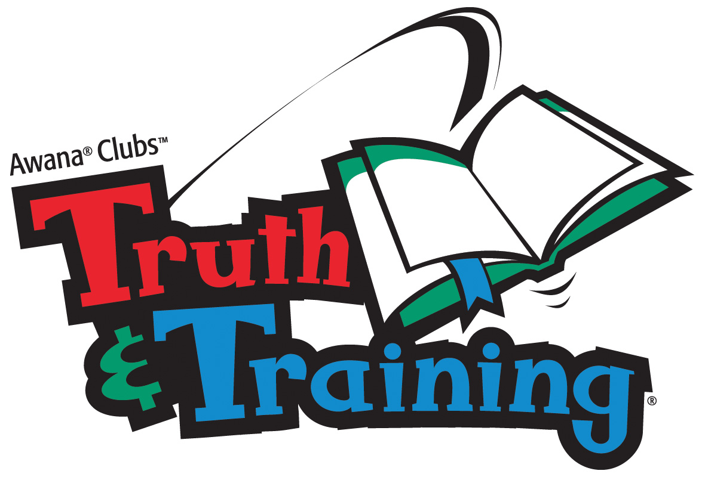

Dear Parents,
We are pleased to have your child involved in our children’s ministries here at Rose Park Baptist Church! What a privilege it is to work together with you in the spiritual, mental, social, and physical training of your child. Awana provides a local church sponsored program for children, regardless of religious affiliation, where they can enjoy exciting games and activities, meet new friends, and learn about God and His Word, the Bible.
Awana Club begins promptly at 6:25 p.m. Children should arrive no earlier than 6:15 p.m. Upon arrival, Sparks and T&T will check in (Awana bucks given for wearing uniform and bringing Bible and handbook) at the designated table in the Adult Sunday School area. Cubbies will check in inside the children’s building. All clubbers MUST be dropped off and picked up by pre-registered parent or guardian. Visitors always welcome!
The first step in the clubber’s advancement is the Entrance Booklet. Please help your child learn each section, word perfect, in the order presented. Upon completion of the Entrance Booklet, your child may become an official member of Awana Clubs and obtain a uniform to display their achievement awards and patches.
Please feel free to contact me if you have any questions or concerns.
In His Service,

Diana Duncan, Children’s Director and AWANA Commander

Dear Parents,
Welcome to another year of AWANA Clubs at Rose Park Baptist Church. We are looking forward to another fun year for the children as they spend time with their friends learning about God’s Word and discovering how they can apply it to their lives. Please make a special effort to spend time with your child each week preparing for AWANA. Through the handbooks, your child will grow closer to God and learn how to serve Him.
We are pleased to have your child involved in our Children’s Ministry here at Rose Park Baptist Church! What a privilege it is to work together with you in the spiritual, mental, social, and physical training of your child. Please feel free to contact me at the church office at 318-687-8272 if you have any questions or concerns.
In His Service,

Diana Duncan, Children’s Minister and AWANA Commander
diana@roseparkbaptist.org

Program Overview

What is AWANA?

Approved Workmen Are Not Ashamed
… Based on the Scripture 2 Timothy 2:15

AWANA provides a local church sponsored program for children, regardless of religious affiliation, where they can enjoy exciting games and activities, meet new friends, and learn about God and His Word, the Bible.
AWANA is:
- Centered on the Gospel
- Focused on Scripture Memory
- Exciting and Fun
- Training Children and Youth to Serve
- Built on Leadership

Rose Park Baptist Church has participated in the AWANA program since 2008.

We offer the following clubs:

- Puggles Toddlers
- Cubbies 3 to 5 Year Olds, 2 years prior to Kindergarten
- Sparks Kindergarten through 2nd Grade
- Truth and Training Ultimate Adventure, 3rd and 4th Grade
Ultimate Challenge, 5th and 6th Grade

CLUB STRUCTURE

AWANA provides weekly club meetings, divided into the following activities:
1. Opening Ceremony—Sparks and T&T start each club night with an Opening Flag Ceremony. Clubbers say pledges, sing the AWANA song, quote the theme verse and pray.

2. Handbook Time – All clubs (except Puggles) dedicate time to Bible Scripture memorization and application using age-appropriate handbooks. All Bible verses are taken word-for-word from the King James Version (KJV) of the Bible. Clubbers should be studying their handbooks during the week, and are rewarded each week according to their progress.

3. Council Time/Story Time – Clubbers enjoy a time of worship through music. As well, all clubs are presented with an age-appropriate Bible message, often including a presentation of the gospel message of salvation through faith in Jesus Christ.
4. Game Time – Sparks and T&T practice teamwork and good sportsmanship by competing in fun and organized games. Please have your children wear clothing appropriate for Game Time (no flip-flops, etc).
5. Award Time – Clubbers are recognized for completing sections in their handbooks.

Club Night Schedules
CUBBIES
6:15-6:30 | 6:30-6:35 | 6:35-7:00 | 7:00-7:20 | 7:20-7:30 | 7:30-7:45 | 7:50-8:00
Coming-In Time | Starting Time | Story/ Singing Time | Book Time | Snack Time | Play Time | Closing Ceremony/ Awards
SPARKS AND T&T
CLUB/ ROOM | 6:15-6:25 | 6:25-6:35 | 6:35-7:00 | 7:00-7:25 | 7:25-7:50 | 7:50-8:00
Sparks | Check-In | Opening Ceremony | Large Group Time | Handbook/ Small Group Time | AWANA Game Time | Closing Ceremony/ Awards
 | Adult SS Dept. | Adult SS Dept. | Lg. Group Room: Adult SS Dept. | Designated Rooms: Adult SS Dept. | Game Circle: Gym | AWANA Square: Gym
Truth & Training | Check-In | Opening Ceremony | Handbook/ Small Group Time | AWANA Game Time | Large Group Time | Closing Ceremony/ Awards
 | Adult SS Dept. | Adult SS Dept | Designated Rooms: Adult SS Dept | Game Circle: Gym | Lg. Group Room: Adult SS Dept | AWANA Square: Gym

Handbook Requirements
Handbooks are an essential part of the AWANA program. Every club (except Puggles) has its own set of handbooks, and every clubber should be working to complete their handbook before the end of the year.

Any time a child enters a new club, the first thing they must do is complete an entrance booklet. Once completed, usually in 2 to 3 weeks, the clubber is given a uniform, a handbook, and a book bag.

All handbooks (even the entrance booklets) are divided into sections. Clubbers should study their sections at home during the week, and at their next AWANA meeting a leader will sit with them one on one and review their sections. When a clubber completes a section, the leader signs off on that section.

Most sections involve memorizing Bible verses. Clubbers should be memorizing these verses (including the verse reference) at home, and must recite these verses from memory when reviewing sections with a leader. The leader is allowed to give the clubber two "helps" per section (not per verse). The requirements of the section must be completed in a single sitting in order to complete the section. Clubbers are limited to complete a maximum of five sections per club meeting.

Cubbies
The entrance booklet for Cubbies is called the Bear Hug Brochure. Once that is completed, all Cubbies will be working in the Jumper book together. The sections in the Jumper book are referred to as Bear Hugs. Cubbies all progress at the same rate, one Bear Hug per week. Each week parents need to read the Bear Hug material to their children, help them memorize the verse at the end of the section, and sign off the section when they've learned it. Apple Tree sections are optional, for extra credit.
Unlike other clubs, Cubbies do not earn shares for their sections.

Sparks
The entrance booklet for Sparks is called Flight 3:16. From there, clubbers work in order through three books: HangGlider, WingRunner, and SkyStormer. A clubber cannot start the WingRunner book unless they are in 1st grade, and cannot start the SkyStormer book unless they are in 2nd grade. Extra credit work is available for clubbers who finish their books early.
Clubbers progress at their own pace in Sparks, but in order to complete one book in a year they must complete 40-49 sections, so their goal should be to complete 2 sections per week.
Sections in the Sparks books are grouped into a Rank Path, four Red Jewels and four Green Jewels. All sections in the book must be completed in order.

Truth and Training
The entrance booklet for T&T is called the Start Zone. (There are two Start Zones, one for 3rd and 4th graders, and one for 5th and 6th graders.) From there, clubbers work through either the two Ultimate Adventure books for 3rd and 4th grades, or the two Ultimate Challenge books for 5th and 6th grades. A clubber cannot start Ultimate Adventure Book 2 until they enter 4th grade, and cannot start Ultimate Challenge Book 2 until they enter 6th grade.
Clubbers progress at their own speed in T&T, but in order to complete one book in a year they must complete 56 sections, so they should be working on at least 2 or 3 sections per week. Gold and Silver sections are extra credit.
Sections in the T&T books are grouped into eight Discoveries for the Ultimate Adventure and eight Challenges for the Ultimate Challenge. Each Discovery/Challenge must be completed in order.

Bringing Visitors-- All Sparks and T&T handbooks have a section that requires your child to bring a visitor to an AWANA meeting. These sections may be completed at any time during the year. If your child is unable to bring a visitor, contact your Director for a list of Alternative Activities.

AWARDS AND REWARDS
The AWANA curriculum is fun, but it is also a lot of work! As such, we like to award and reward our clubbers for their achievements:
- AWANA Bucks: Sparks and T&T clubbers earn “shares/bucks” during the year for completing sections in their handbook, as well as other activities. These shares can then be redeemed in the AWANA Store (held two times per year) for various prizes.
- Uniform Awards: After reaching specific milestones in their handbook, clubbers are presented with awards which attach to their uniform.
- Attendance Awards: Good Club and Church Attendance is recognized quarterly
- Book Awards: At our Year-End Awards Ceremony, Book Awards are presented to all clubbers who have completed their handbook this year.
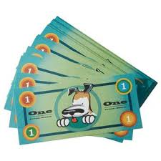

PARENTAL PARTICIPATION
Parents are requested to participate in the following areas:
- PRAY for your children and their AWANA leaders!
- Encourage and help your child in Scripture memorization. This is important for all age levels, but especially for Cubbies and Sparks who cannot yet read.
- Deliver and pickup your child promptly for all club meetings and functions. Check-in for Puggles, Cubbies, Sparks, and T&T starts at 6:15 P.M.
- Encourage and help your child to attend Church and Sunday School.
- Encourage and help your child to attend each weekly club meeting.
- Make sure that your child brings their Start Zone or handbook and Bible each night to club. If they do not have a Bible, please contact their Director. No child should be trying to complete their handbooks without a Bible.
- Stress to your child the importance of the Club Rules below.
- Assist and encourage your AWANA Leaders. These dedicated Leaders help promote every child's growth! Contact them if you have any questions or concerns.

Please Note: Parents, you must fill out and sign the Registration Form and return it by your child’s second visit. You must complete this form every year, even if you have registered with us in the past.

CLUB RULES FOR CLUBBERS
Clubbers should follow these rules:
- Please be on time. Club meetings will start promptly at 6:25 PM, and check-in for Cubbies, Sparks and T&T starts at 6:15 P.M.
- Wear your uniform every week. Clubbers cannot receive awards or present flags unless they are in uniform.
- Do not bring any toys, games (Nintendo DS, PSP, etc.), iPods/MP3 players, cell phones, trading cards (except T&T trading cards), or sports equipment (footballs, etc.) to Club meetings.
- Wear tennis shoes and long pants for protection during Game Time, if you are in Sparks or T&T. This is recommended, not required, but you may not be allowed to participate in games if you do not follow this rule.
- Obey your Leaders! Disobedience cannot be tolerated.
  - Display Care and Respect for all church property and for others
  - No foul language or gestures will be used, before, during, or after club.
  - No Running before, during, or after club except for during Game Time.

General Guidelines and Discipline
The purpose of discipline is to teach acceptable behavior, not merely a set of rules. By setting and enforcing club standards, AWANA leaders attain a consistent standard of acceptable conduct.
AWANA uses a five-count method to bring order and quiet. This is for the whole group. The Director or person in charge will slowly count 1-2-3-4-5, at which time there should be absolute silence.
AWANA uses a three-count method as a discipline device. This is used anytime during the club to discipline individual clubbers who are disruptive or misbehaving. The clubber will be warned by the Director or person in charge with a count of “1”. If misbehavior continues they will be warned again with a count of “2” and may be taken to the Commander for counseling. If clubber still refuses to behave appropriately, they will receive a “3” and their parents will be called.
Game Time is a privilege, and we do not want anyone to miss it. In the case of misbehavior, however, Director/Commander may revoke Game Time privileges for a night as an act of discipline.

August  24–AWANA Workers Mtg  27-AWANA Ministry Conference in Haughton | September  7–AWANA Kick-Off  14--Regular Club  21-- Regular Club  28--Regular Club | October  5—Paper Airplane Night  12-- Regular Club  19-- Regular Club  26-- Regular Club | November  2—Bring a Card for Our Homebound Night  9 – Regular Club  16– Regular Club  23– No AWANA: HAPPY THANKSGIVING!  30-- Regular Club
December  7 – Tree Trimming Night  14 – AWANA Christmas Store  21 – No AWANA  28 – No AWANA | January  4 – Hawaiian Luau Night  11 – Regular Club  *1/2 Way There Night Party*  18 – Regular Club  25 – Regular Club | February  1 – Nonsense Olympics Night  8— Regular Club  15- Regular Club  22-- Regular Club  23- Regular Club | March  7 –Measles Night  14 - Reg. Club  21 – Reg. Club  28 – No AWANA: Spring Break
April  4 – “I want to be” Night  11 – Regular Club  18– Regular Club  25 – Regular Club | May  2 – AWANA Game Show Night  9 - Regular Club  16 – AWANA End of Year Store  20 – AWANA Awards Night | See the following listing for details of each night and how to prepare. | 
*Theme Nights will be on the first Wednesday night of each month.


- September 7th: AWANA Kick-Off Night: Everyone come dressed in their favorite football jersey or shirt.
- October 5^{th:} Paper Airplane Night: Bring a paper plane covered with your own colors and design. Prizes for the farthest, best looping and straightest flight.

- November 2^{nd:} Bring a Thanksgiving Card for our Homebound: Everyone is encouraged to bring a homemade card to send to our Homebound Members.
- December 7th: Tree Trimming Night and Decorate a Leader Night: Clubbers are encouraged to bring a homemade Christmas ornament for the tree and we will have fun decorating our directors for the season.
- December 15^{th:} AWANA Christmas Store - To make AWANA extra rewarding, we have the AWANA Store which is a reward for your clubber(s) hard work for all that they in do in AWANA. They will receive “AWANA Bucks” to spend as real money toward prizes and gifts. We need your help with any donations of prizes or candy to help stock the store. The Christmas Store is extra special in that we have Christmas gifts for your clubber(s) to buy for you (their family members). Any donations of $5.00 and under gifts for this store are also appreciated.
- January 4th: Hawaiian Luau Night: Think forward to summer and dress in your favorite Hawaiian gear!
- February 1st: Nonsense Olympics Night: Clubbers will enjoy some extra fun and silly Olympic style games during game time.
- March 7th: Measles Night: For every verse a clubber says, one red dot on will be placed on their leader. We’ll see who gets the worst case of the measles! That leader’s group will receive a treat at the end of the evening!
- April 4^{th:} “I want to be” Night: Clubbers come dressed up in what they wish to be one day!
- May 2nd: AWANA Game Show Night: A Game Night for Extra AWANA Bucks!
- May 16th: AWANA Store Night: Clubbers will get to cash in their AWANA bucks for prizes! Don’t forget your $$$$.

Special Notes
Club Dismissal
Puggles will be dropped off and picked up in the Nursery Suite.
Cubbies will drop-off inside the Children’s building and pick up from the gym.
Sparks and T&T will drop-off and pick up from the gym. All clubbers will stay on their color line until they are picked-up by parents. Parents please come for the 7:50 p.m. Closing Ceremony and cheer for your clubber as awards are presented.
All clubbers should be picked up no later than 8:00 p.m.
Closing Ceremony / Awards
Each club night for Cubbies, Sparks and T&T will end with a closing ceremony in the gym starting at 7:50 p.m., with clubbers receiving their awards for the night. All parents and grandparents are asked to stand behind their clubber(s) during this special time!

Club Expenses Price List

Many churches fund their AWANA Ministry by collecting dues from their clubbers and having them purchase their uniforms, handbooks, and bags. However, due to the generosity of Rose Park Baptist Church, you will not be asked to pay for any of this. The church will supply everything needed to start in our AWANA program. Please note that each clubber is encouraged to take special care of their handbooks, uniforms and bags, as replacement fees may apply.

 | Puggles | CUBBIES | SPARKS | T&T
Handbooks | N/A | $9 | $10 | $9
Uniforms | $9 | $10 | $12 | UA - $13  UC - $14
Bags | N/A | $6 | $5 | $6

- Beth Maddox, Leader
- AWANA Puggles is an enriching program for your pre-Cubbies kids that presents basic biblical concepts:
- We are a unique creation of God.
- God loves us very much.
- AWANA Puggles teaches toddlers simple lessons through teaching cards, activities, music and more.
- AWANA Puggles leaders have a leader’s guidebook to help them plan and direct club time and communicate the lesson.
- Then parents—an AWANA Puggle’s first and best teacher—can step in to reinforce the lessons with take-home cards that include ideas to point out God’s work each day. And little details like AWANA Puggles T-shirts, puzzles and coloring books make every precious child feel like part of the group.
- AWANA Puggles is a club that plants seeds of faith and teaches toddlers God’s Word!
- Drop your child off in the Nursery and they will be transported during Puggle Time to the Pre-K 3 Room at the end of the Nursery Suite. One parent or guardian must remain on campus during AWANA.
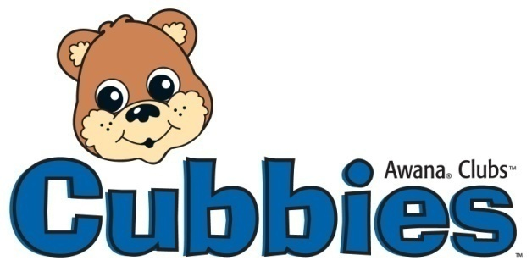
- Cheryl Brister, Director / CFBrister@Comcast.net / (318) 465-3279
- Cubbies Club is for boys and girls 3 & 4 years old (2 years prior to kindergarten).
- Cubbies enjoy many different activities. Cubbies will learn by seeing, hearing, doing, and playing.
- Cubbies will learn verses in one section each week. All Cubbies should be working on the same verse (section) each week.
- Cubbies have 2 books to complete (year 1 and year 2). They will receive a Cubby Bear award for their first book and a Ribbon for their second book.
- Parents especially need to set aside time to help their Cubby learn the upcoming week’s verse.
- Cubbies will have 30 sections to learn throughout the year.
- One parent or guardian must remain on campus during AWANA.


- Tammy Snellgrove, Director / peasemeadow@gmail.com / (318) 949-6391.
- Sparks Club is for boys and girls in Kindergarten, 1st and 2nd grade.
- Sparkies will have the opportunity to complete three books in three years, but are encouraged to work at their own pace.
- In order to complete one book per year and receive a review patch, the Sparky should be prepared to pass two sections per night.
- Upon completion of their entrance booklet, the Sparky will earn their vest. This should be worn each week to club.
- Once they pass a few more sections, they will earn their wings. The wings hold the red, green, and blue jewels the clubbers earn by completing sections.
- The Sparkies will earn a ribbon for each book they complete. If a clubber completes all three books, they will receive the Sparky Award

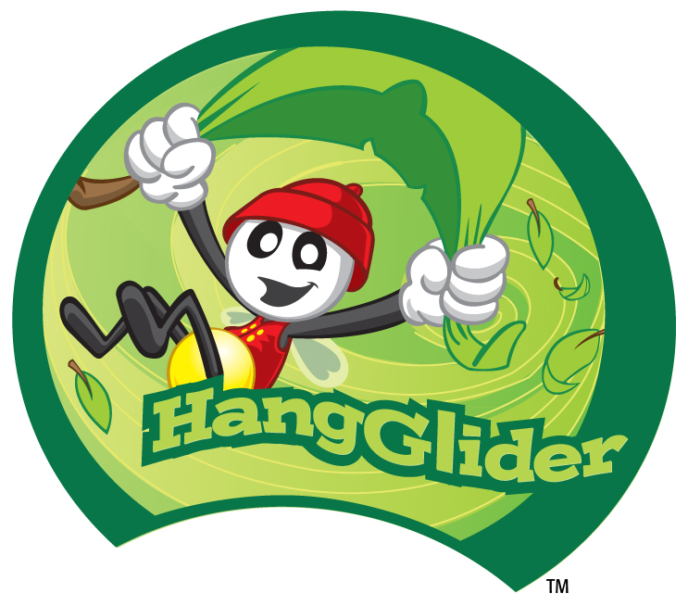

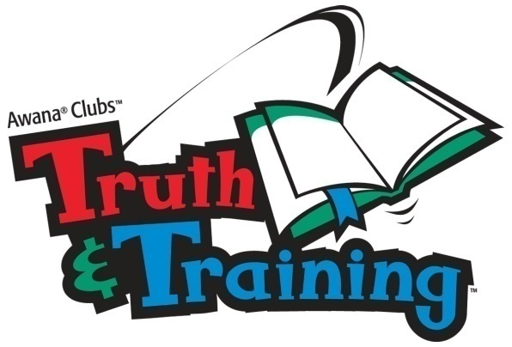
- Sharon Darnell, Director / shrnann2009@aol.com / (318) 938-1918

- T&T is a club for boys and girls in the 3rd through 6th grades.

- T&T is divided into two sub- clubs. The Ultimate Adventure is for 3rd and 4th graders and the “upper” club for 5th and 6th grades is The Ultimate Challenge.

- The Ultimate Adventure uniform is a green t-shirt and the Ultimate Challenge uniform is a blue and white soccer style jersey.

- All new Clubbers to T&T will complete the Start Zone (Entrance Booklet) and will then receive their handbook, uniform and bag.

- Each club (Ultimate Adventure and Ultimate Challenge) will have the opportunity to finish two books in two years for a total of four books.

- There are 56 sections (contained in 8 subsections entitled Discoveries/Challenges) to be completed during the 32 weeks of club. Clubbers will have to say, on average, 2 sections per club night to complete their appropriate handbook.

- Ultimate Adventure Clubbers will receive a badge to display awards earned for passing a Discovery.

- Ultimate Challenge Clubbers will select a patch of their choice to be displayed in the white area of their jersey uniform for each Challenge passed.

- All T&T Clubbers will receive awards at the end of the year for completing their handbook(s).


